Chapter 7 Reproduction of Organisms Lesson 1 Sexual Reproduction and Meiosis
Sexual Reproduction
- Sexual reproduction is a type of reproduction in which the genetic materials from two different cells combine, producing an offspring.
- The cells that combine are called sex cells.
- The female sex cell is an egg (forms in ovaries).
- The male sex cell is a sperm (forms in testes).
- During fertilization an egg and a sperm cell join together and produce a new cell called a zygote.

Diploid Cells
- Following fertilization a zygote goes through mitosis and cell division and produces nearly all the cells in a multicellular organism.
Organisms that reproduce sexually produce two types of cells:
- Body cells
- Sex cells
In the body cells of most organisms similar chromosomes occur in pairs.
Diploid cells are cells that have pairs of chromosomes.

Chromosomes
Homologous chromosomes are pairs of chromosomes that have genes for the same traits arranged in the same order.
- Because one chromosome is inherited from each parent, the chromosome are not identical.
Example:
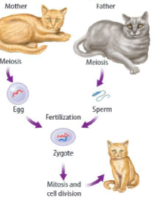
Because one chromosome is inherited from each parent, the chromosomes are not always identical. For example, the kittens above inherited a gene for orange fur color from their mother. They also inherited a gene for gray fur color from their father. Some kittens might be orange, and some kittens might be gray. Both genes for fur color are found at the same place on homologous chromosomes, but they code for different colors.

Different organisms have different number of chromosomes. Remember diploid cells have pairs of chromosomes.
- Human diploid cells have 23 pairs of chromosomes for a total of 46 chromosomes.
- A fruit fly diploid cell has 4 pairs of chromosomes for a total of 8 chromosomes.

Haploid Cells
Sex cells (egg and sperm cells) have only ONE chromosome from each pair of chromosomes.
Haploid cells are cells that only have one chromosome from each pair.
Organisms produce sex cells using a special type of cell division called meiosis.
In meiosis on diploid cell makes four haploid cells.
The Phases of Meiosis
Remember that mitosis and cytokinesis involve only one division of the nucleus and cytoplasm.

Meiosis involves two cell divisions of the nucleus and the cytoplasm. These cell divisions are called:
- Meiosis I
- Meiosis II

The results is 4 haploid cells – cells with half the number of chromosomes as the original cell.

Meiosis occurs only during the formation of sex cells.

Phases of Meiosis I
A reproductive cell goes through interphase before beginning meiosis I. During interphase, the reproductive cell grows and copies, or duplicates, its chromosomes. Each duplicated chromosome consists of two sister chromatids joined by a centromere.
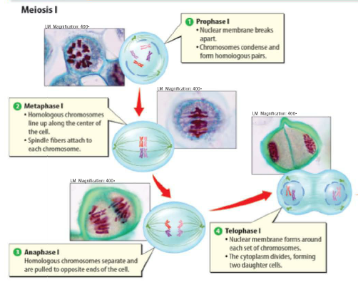
- Prophase I
During prophase I, duplicated chromosomes condense, or shorten, and thicken. Homologous chromosomes come together and form pairs. The membrane around the nucleus breaks apart and the nucleolus disappears.

- Metaphase I
During metaphase I, homologous chromosome pairs line up along the middle of the cell, as shown in the figure above. A spindle fiber attaches to each chromosome. 3. Anaphase I During anaphase I, chromosome pairs separate and are pulled toward opposite ends of the cell. Notice in the figure above that the sister chromatids stay together.

- Anaphase I
During anaphase I, chromosome pairs separate and are pulled toward opposite ends of the cell. Notice in the figure above that the sister chromatids stay together.

- Telophase I
During telophase I, a membrane forms around each group of duplicated chromosomes. The cytoplasm divides through cytokinesis, and two daughter cells form. Sister chromatids remain together.

Phases of Meiosis II

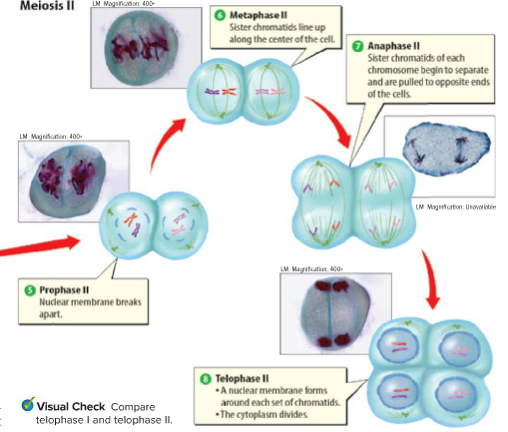

After meiosis I, the two cells formed during this stage go through a second division of the nucleus and the cytoplasm. This process is called meiosis II.

- Prophase II
Unlike prophase I, chromosomes are not copied again before prophase II. They remain short and thick sister chromatids. During prophase II, the membrane around the nucleus breaks apart, and the nucleolus disappears in each cell.

- Metaphase II
During metaphase II, the pairs of sister chromatids line up along the middle of the cell in single file.
- Anaphase II
During anaphase II, the sister chromatids of each duplicated chromosome are pulled apart. They then move toward opposite ends of the cells.
- Telophase II
The final phase of meiosis is telophase II. During telophase II, a nuclear membrane forms around each set of chromatids. The chromatids are again called chromosomes. The cytoplasm divides through cytokinesis, and four haploid cells form.
Why is meiosis important?
Meiosis is important to sexual reproduction. It forms the correct haploid number of chromosomes. This maintains the correct diploid number of chromosomes in organisms when sex cells join. Meiosis also leads to genetic variation.

Meiosis helps maintain diploid cells in offspring by making haploid sex cells. When haploid sex cells join together during fertilization, they make a diploid zygote, or fertilized egg. The zygote divides by mitosis and cell division and creates a diploid organism.

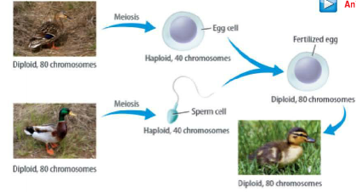
How do mitosis and meiosis differ?

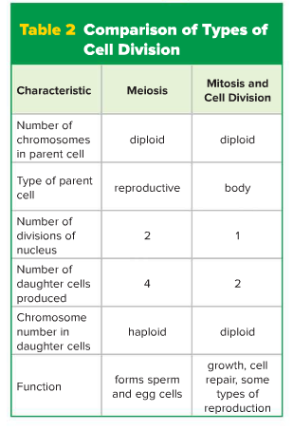

Advantages of Sexual Reproduction
- The main advantage of sexual reproduction is that it results in genetic variation among offspring. Offspring inherit half their DNA from each parent. Inheriting different DNA means that each offspring has a different set of traits.
1. Genetic Variation
- Genetic variation occurs in all organisms that reproduce sexually
- Some people have blue eyes; others have brown eyes. Some people have blonde hair; others have red hair.
Because of genetic variation, individuals within a population have slight differences. These differences might be an advantage if the environment changes. Some individuals might have traits that make them able to survive harsh conditions. For example, some plants within a population might be able to survive long periods of dry weather. Sometimes the traits might help keep an organism from getting infected by a disease.

2. Selective Breeding
- Selective breeding is a process that involves breeding certain individuals within a population because of the traits they have.

For example, a farmer might choose plants with the biggest flowers and stems. These plants would be allowed to reproduce and grow. Over time, the offspring of the plants would all have big flowers and stems.

Disadvantages of Sexual Reproduction
1. Sexual reproduction takes time and energy. Organisms have to grow and develop until they are mature enough to produce sex cells.
2. Before they can reproduce, organisms have to find mates. Searching for a mate takes time and energy.
3. The search for a mate might expose individuals to predators, diseases, or harsh environmental conditions.
4. Sexual reproduction can be limited by certain factors. For example, fertilization cannot take place during pregnancy, which can last as long as two years in some mammals.

